|  |  |
| --- | --- |
|  | **Harrisdale Senior High School**  **Science Department** |

**ATAR Physics Units 1 and 2**

**Task 8: Waves Investigation 2022**

|  |  |
| --- | --- |
| **Student name:** |  |
| **Teacher name:** |  |
| **Date:** |  |

**Background**

When brass and woodwind instruments are played, sound waves travel through the pipes that they are made of. When a compression meets a rigid or fixed surface, the particles push against the surface. The surface pushes back on the particles according to Newton’s third law, sending a compression back in the opposite direction.

When a compression reaches an open end, however, it diffracts outwards, pulling more air out of the pipe with it. The rest of the air in the pipe moves up to take the place of this ‘missing’ air, causing a rarefaction to travel in the opposite direction. If the rarefaction reaches another open end, the higher-pressure air outside the pipe rushes in, sending a compression in the original direction.

At certain frequencies, these reflected waves interact with incident waves to create **standing waves**: large amplitude waves with stationary points of total destructive interference (nodes) and significant constructive interference (antinodes). These standing waves are often represented using diagrams showing longitudinal particle displacement throughout the pipe, as can be seen below.

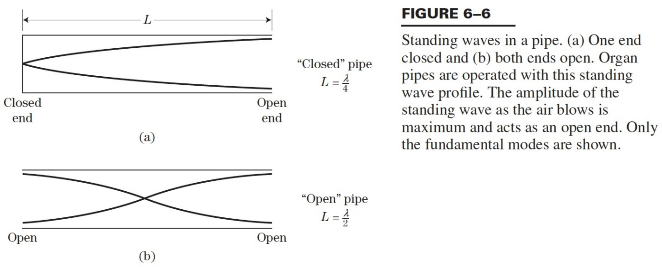

**Aim**

In this assessed investigation, you will use a measuring cylinder, an open-ended pipe, and a set of tuning forks to experimentally determine the speed of sound.

**Method**

1. Collect all equipment.
2. Fill the measuring cylinder with water and hold the transparent tube so that it is partially submerged.
3. Strike the tuning fork and hold it above the transparent tube.
4. Slowly raise the tube, listening to the sound as you do.
5. When the sound becomes louder, you have found the first harmonic. Measure and record the length of pipe that is above the water.
6. Conduct a total of three trials and tabulate your results.
7. Repeat the experiment with tuning forks of four different frequencies.
8. Use your results to calculate the speed of sound.
9. Measure the air temperature and calculate the expected speed of sound using the formula below. (*T* = air temperature in °C)
$$v=331\sqrt{1+\frac{T}{273}}$$

10. Calculate the percentage error between your actual value (*vA*) and your expected value (*vE*).

**Analysis and Discussion**

Draw a table containing the data that you obtained for this experiment. Complete any necessary calculations below it.